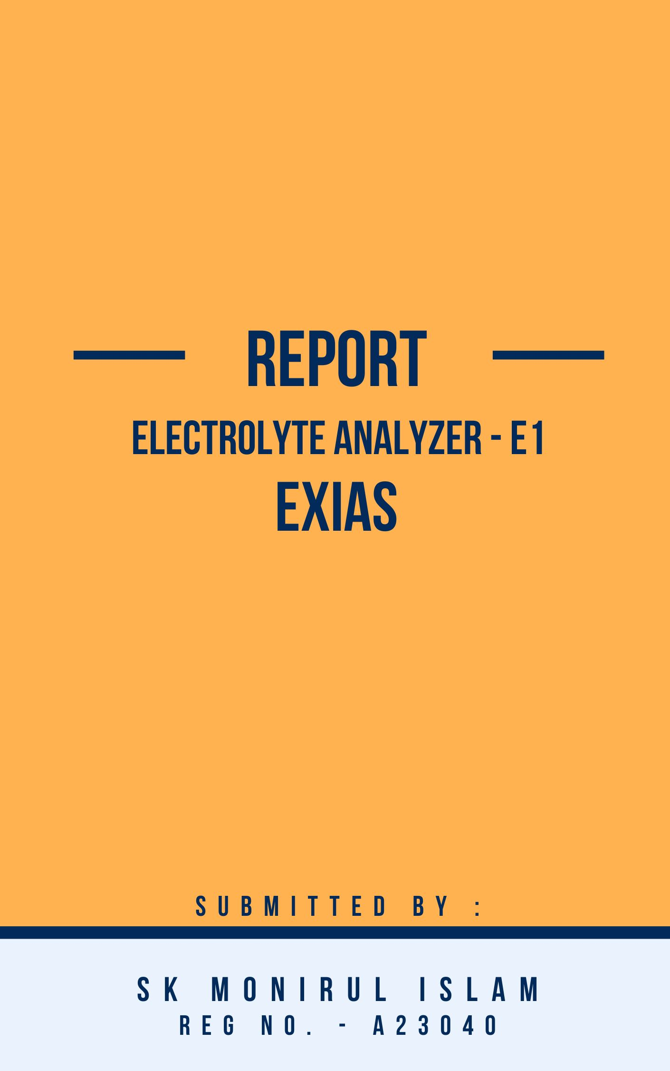

Company Background

EXIAS Medical was founded in 2014 and has been growing continuously. Our profession is the development, manufacturing and sales of in-vitro-diagnostic (IVD) analyzers in the point-of-care and laboratory field.

As a distinct manufacturer of measurement systems and accessories, we set new standards through performance, usability and high-quality. In addition, we operate as an OEM partner for providers in the field of clinical chemistry.

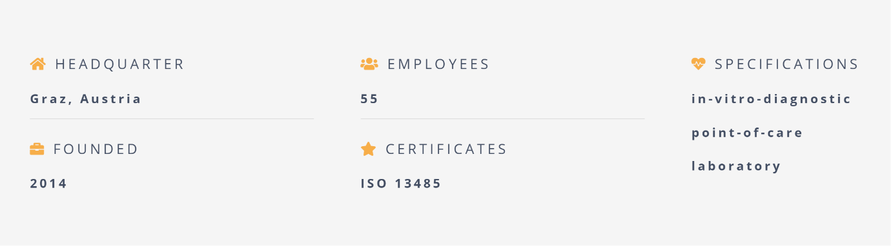



Product Overview:

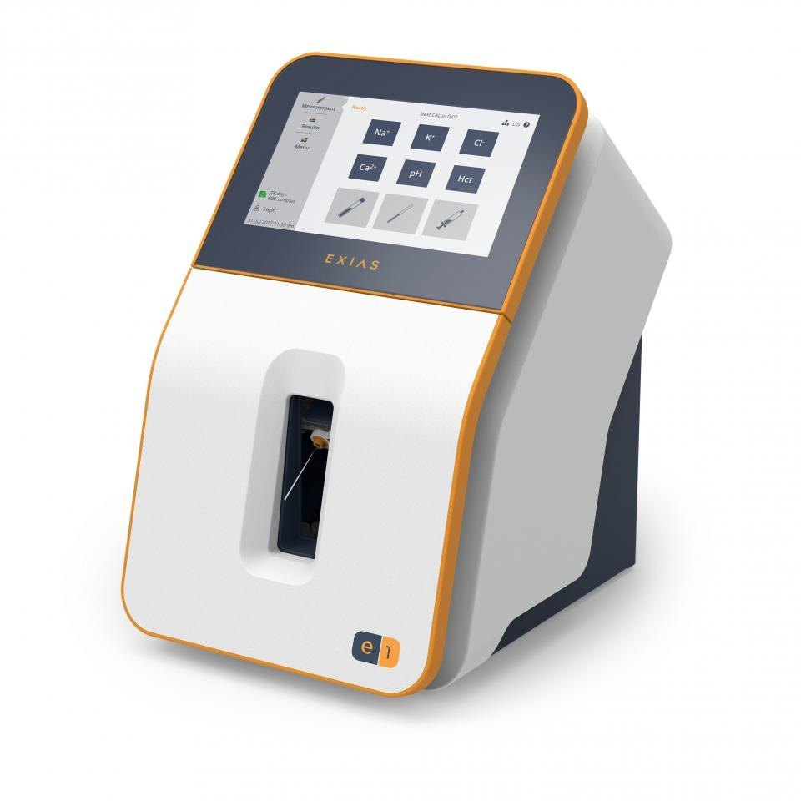

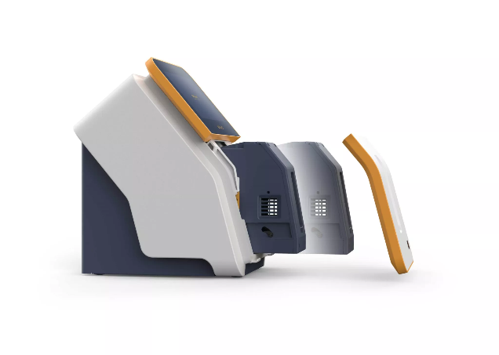

The EXIAS e|1 Analyzer is an electrolyte system intended for in-vitro measurements of Na+, K+, Cl-, Ca2+ as well as pH and Hct, in whole blood, serum, plasma and urine (undiluted).

High accuracy, ease of use and the maintenance free system underline the operational functionally and outstanding performance of our e|1 Analyzer.

Robust and clever design combined with a compact footprint make the e|1 Analyzer well suited for both point-of-care environment and laboratory.

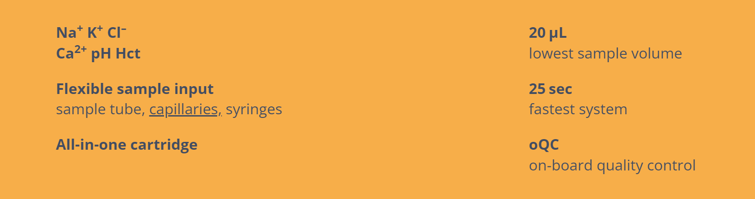

Product Value Proposition:

The EXIAS e|1

Ease of Use: The analyzer boasts a simple and intuitive design, making it suitable for various healthcare settings.

Maintenance-Free: The all-in-one cartridge eliminates the need for routine maintenance, reducing downtime and overall costs.

Fast and Accurate Results: The e|1 Analyzer delivers results in just 25 seconds with high accuracy.

Low Sample Volume: The analyzer requires only 20 microliters of sample, minimizing patient discomfort.

Flexible Sample Input: The system accepts samples from various sources like tubes, syringes, and capillaries without requiring adapters.

Compact Footprint: The small size of the analyzer makes it ideal for use in space-constrained environments.

Key Product Performance Parameters:

Test Parameters: Sodium (Na+), Potassium (K+), Chloride (Cl-), Ionized Calcium (Ca2+), pH, and Haematocrit (Hct)

Sample Volume: 20 microliters

Analysis Time: 25 seconds

Cartridge Capacity: 600 samples (28 days), 300 samples (42 days), or 150 samples (42 days) depending on configuration

Calibration Time: 30 seconds for 2-point calibration

Technological Framework:

1. Microfluidics:

Microfluidic devices contain miniaturized channels and chambers that precisely control the flow and manipulation of fluids within the analyzer.

This precise control allows for accurate and efficient processing of small samples, making the e|1 Analyzer suitable for point-of-care testing where sample availability might be limited.

2.Electrochemical Sensors:

The e|1 Analyzer relies on electrochemical sensors to measure the concentration of electrolytes in the sample.

These sensors convert the chemical reactions between the electrolytes and specific reagents into electrical signals.

The microprocessor unit then interprets these signals to determine the electrolyte concentrations.

3. Microprocessor Control:

The MPU controls processes like sample introduction, fluid movement, sensor data acquisition, and analysis calculations.

4. Touchscreen Interface:

The e|1 Analyzer features a touchscreen interface that provides a user-friendly platform for interacting with the device.

Users can initiate tests, view results, access settings, and perform basic maintenance functions through the touchscreen.

Target Consumers:

1. Hospitals and Clinics
2. Emergency Departments
3. Intensive Care Units
4. Physician Offices
5. Care Centres

Go-to-Market Strategy:

Direct Sales Force: A team of sales representatives directly interact with potential customers in hospitals, clinics, and laboratories.

Distributor Network: Partnered with medical equipment distributors to expand their reach and leverage the established distribution channels.

Trade Shows and Conferences: Participating in industry events where they showcase their products to a wider audience.

Website and Marketing Materials: A user-friendly website and targeted marketing materials to educate potential customers about the EXIAS e|1 Analyzer's benefits.

Pricing:

Pricing information for the EXIAS e|1 Analyzer is not publicly available. But in India some distributers sell it at a price of 200000 Inr.

Competitive Analysis:

1. Roche Diagnostics (Switzerland): Established brand reputation.
2. Siemens Healthineers (Germany): Renowned for quality and reliability.
3. Abbott Laboratories (US): Innovative technologies in diagnostics, Compact analyzers available.
4. Horiba Medical (Japan): Focus on accuracy and precision.
5. Mindray (China): Cost-competitive options.







SWOT Analysis:

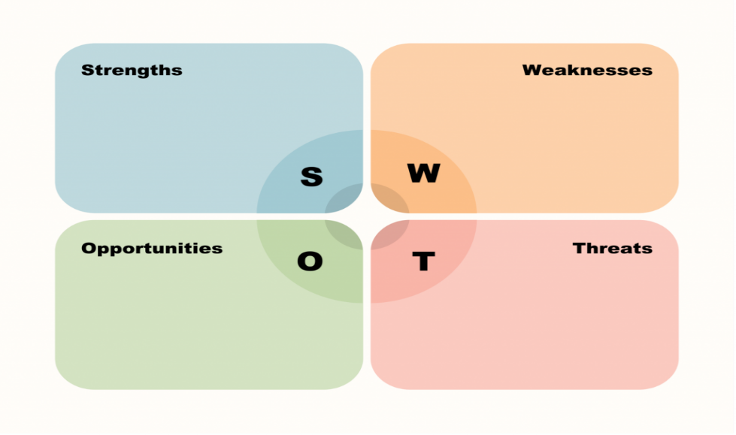rrrrrrrrr

Strengths:

Ease of use and maintenance-free design

Fast and accurate results with low sample volume

Flexible sample input and compact footprint

Broad range of applications

Weaknesses:

Limited availability of pricing information

Potentially higher upfront cost compared to some competitors

Opportunities:

Growing demand for point-of-care diagnostics

Increasing focus on rapid and efficient patient care

Expansion into new markets

Threats:

Competition

Key People Behind the Project:

1. WOLF-DIETRICH STEINBÖCK - Senior Systems Architect
2. Emanuel Kiefer – Systems Engineer